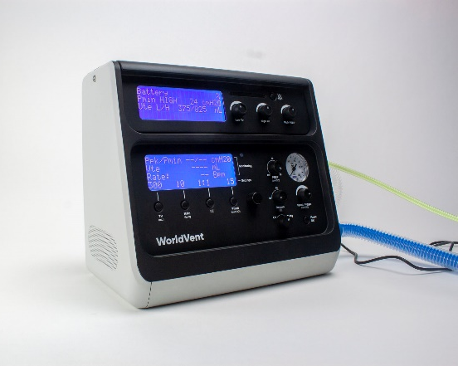

Control Settings:
- Tidal Volume – User Settable: 300 to 900 ml
- Respiratory Rate – User Settable: 10 to 34 Bpm (I:E Maximum 1:1; Minimum 1:12)
- Peak Inspired Pressure – User Settable: 15 to 50 cm H2O
- PEEP Level – User Settable: Off, 5 to 20 cm H2O
- Spontaneous Trigger Sensitivity – User Settable: -10 to -2 cm H2O
- O2 % - Discrete Settings: 60%, 80% and 100%
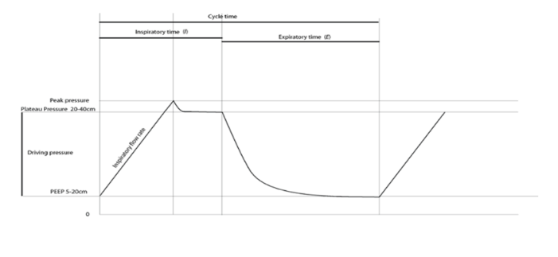
- Inspiratory Flow – Fixed flow at 40 Lpm
- On/Standby switch for suction procedures

Ventilation Mode
- Volume Controlled Ventilation (VCV)
- Assist Control – Spontaneous Effort Triggered VCV breaths
- Inspiratory Pressure Limited at PIP setting with pause
- Pmax safety limit at 60 cm H2O

Monitoring & Alarms
- LCD Digital Display of Ppeak, Pmin, Vte and Rate values updated each breath
- Mechanical Pressure Gauge for visual pressure representation
- Battery and Alarm Status continually displayed
- Alarms include High Paw, High & Low Vte, Circuit Disconnect, Occlusion, On Battery
- Alarm audio tone and color visual indicators
- Uses delta pressure type airway flow sensor (GE D-Lite)

Physical Operation
- Size: 15 cm H x 23 cm W x 27 cm D; Weight: 2.3 Kg
- Electrical Power Input: 12 Vdc Input, 2A (external AC/DC power supply)
- Pneumatic Input: O2 supply at 35 to 87 psi (all O2 delivered to patient)
- Battery Backup: Automatic switchover and recharge with >30 minute operational capacity
- Operating Environment: 10 to 40° C; 15 to 95% RH Non-Condensing
- Storage Environment: -20 to 65° C; 15 to 95% RH Non-Condensing
- Vibration: Meets National Safe Transit Association (NSTA); Procedure 1a
- Standards: Meets ISO 80601-2-12 with IEC 60601-1 Critical Care Ventilator Standards

